Assignment 6

**Upload static website on S3 and run it.**

**Steps for creating an AWS account:**

1. **Sign in.** Sign in as a root user. Provide username and password when prompted.
2. Search on the search bar **S3**. After that click on **bucket** in the **S3**.

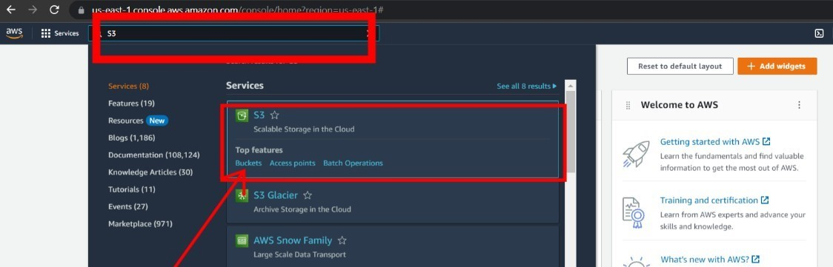

1. Now click on **Create bucket** and create a public bucket.

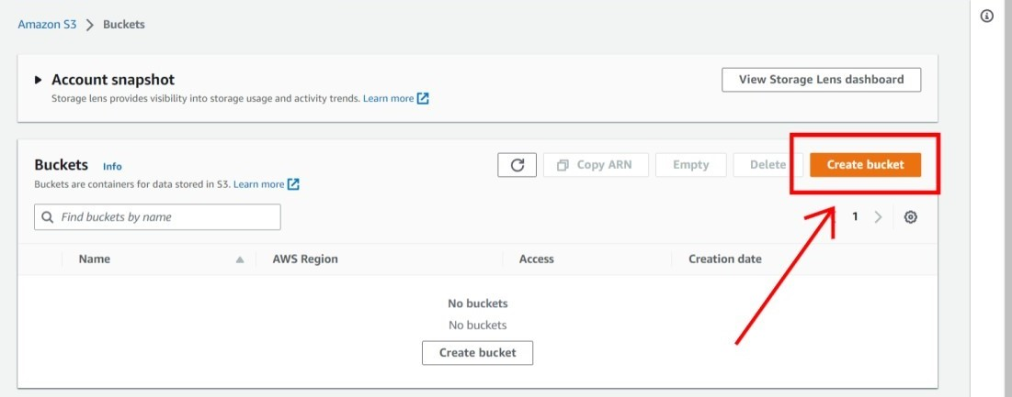

1. Now click on **upload** to upload your static website.

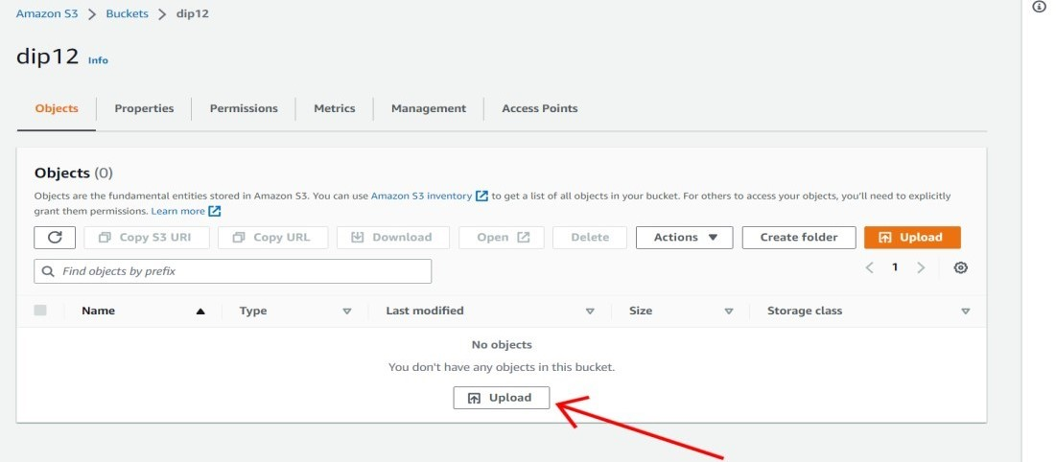

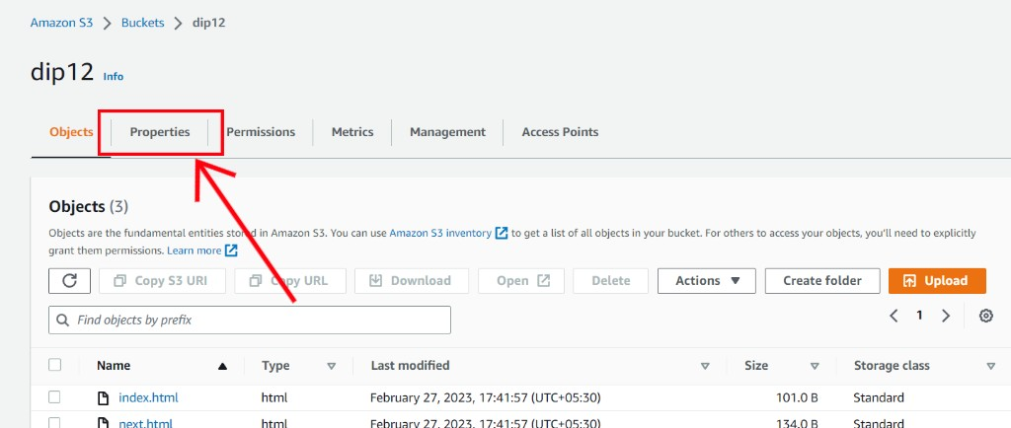

1. In properties scroll down and at the bottom in the **Static website hosting** portion click on

**edit**.

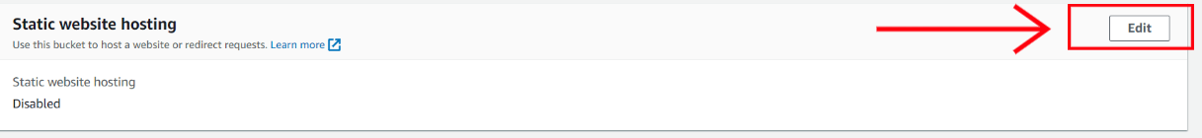

1. After that click on **enable**.

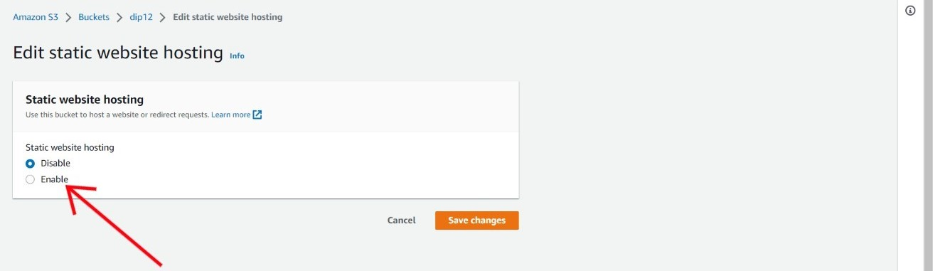

1. After that enter the **index document** name.

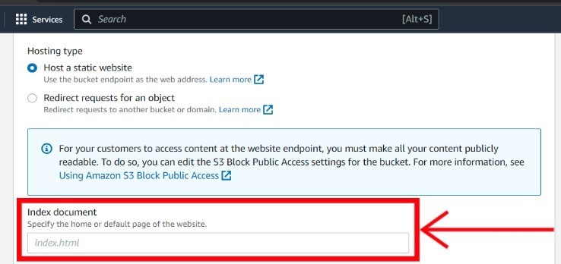

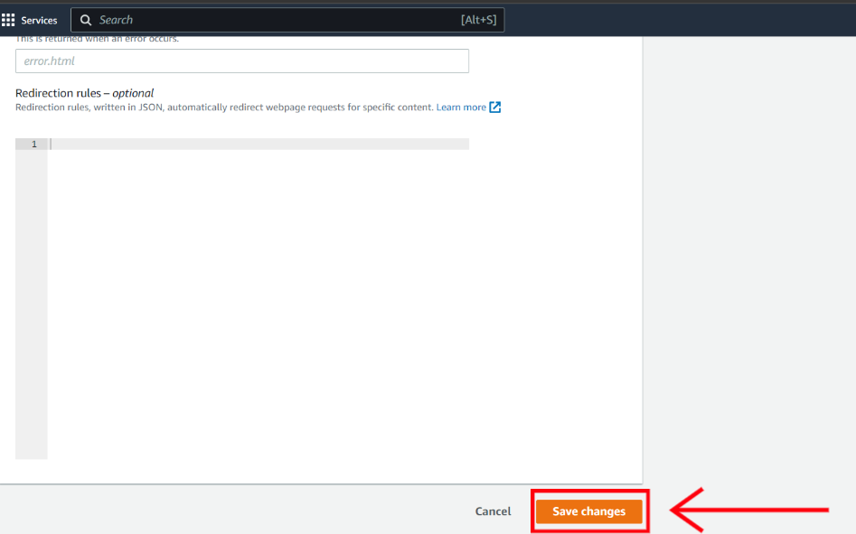

1. After select **all file** that you have uploaded and click on **actions** after that click on **Make public using ACL**.

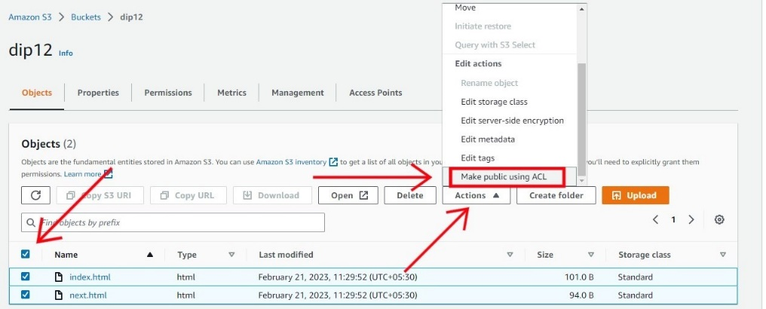

1. After that click on **Make public**.

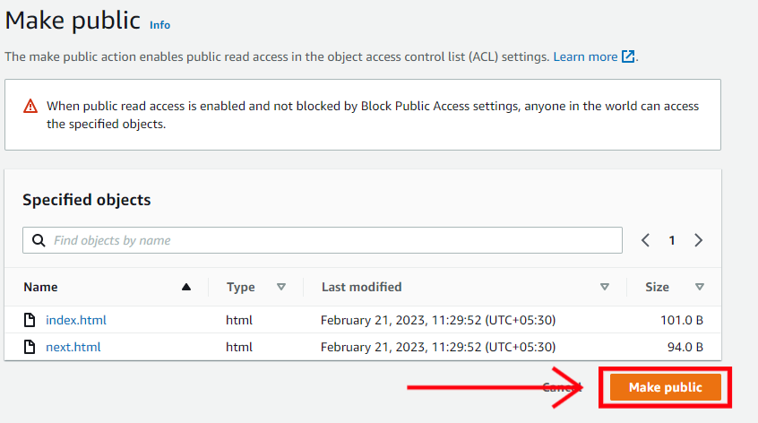

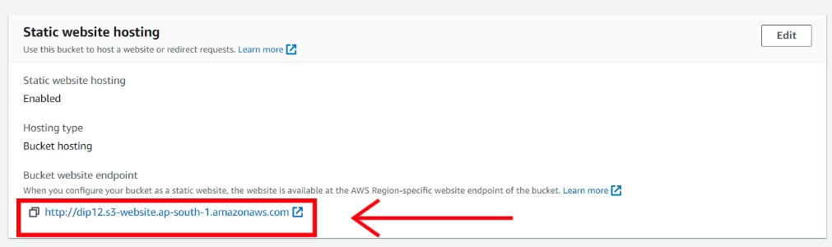

13. You can see that you website is now live.

